National Coalition on the Education Emergency
RESUME and RENEW Education for 26 Crore Children!
Individuals and organizations concerned about the growing Education Emergency in India met virtually on 16 July 2021 to work together as a coalition, to address the crisis that our nation’s children are facing, especially those from the poorest and most disadvantaged groups. The coalition decided to work along two tracks: (i) providing immediate educational support to schools and communities and (ii) influencing authorities through social mobilization to provide equitable and meaningful learning opportunities for all children, and act on related health and livelihood issues.
The primary and defining principle of coalition is equity – the need to ensure that opportunities for learning and development are available to all, in fulfillment of the Right to Education (RTE). We need to build on the many initiatives undertaken by NGOs, some state governments, and district authorities to address this emergency. We call on all those who are interested to contact us, share their experiences and join this collective effort. Information about the meeting is available here.
Contact: info@educationemergency.net | https://EducationEmergency.net

The catastrophic Covid-19 pandemic has snuffed out lakhs of lives. Lock downs have destroyed the livelihoods of millions of people. The horrific images of burning pyres and migrants walking home for hundreds of miles have made visible the health and livelihood emergencies across the country.
But another silent and invisible emergency is threatening to wipe out the livelihoods of poor people in the future and their access to a life of dignity and equality. In many parts of India, the public education system shut its doors to students for the greater part of last year, and will likely continue doing so in the coming year. Thousands of children who have lost one or both parents, and millions affected by the loss of jobs and income and high health expenditures, will need to make a painful choice between working to support their families and coming back to school. School closures have aggravated malnutrition, child abuse, child labor, school dropout, and early marriage. This is what we refer to as the education emergency. Read more about it here.
The education emergency is disproportionately affecting majority of the 26 crore children, who study in government, aided schools and ‘poor’ private schools. Those studying in well-resourced private schools have shifted to online learning, and have access to home support. Therefore, the inequity in education is rapidly worsening.

Resume Education: Establish ‘Education Emergency Rooms’
Children, especially those from disadvantaged groups, need structured learning opportunities and support. We need to take measures to protect children and teachers’ health while providing students with nutrition and meaningful interaction with teachers to continue their education and meet their physical, mental, and socio-emotional development needs.
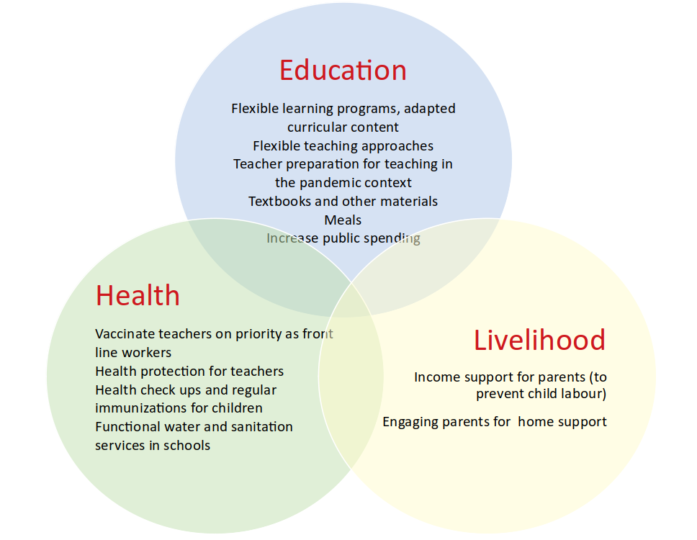
‘Remote learning’, through broadcast TV or radio fails to engage children beyond a point. Many states have shifted to ‘digital education’ without the necessary content and teacher training. It is evident that most children do not have access to the required devices or the internet. Children have also been affected by the inability to interact with teachers and friends.
There is no alternative to resuming formal education in schools, taking into account public health measures.
To tackle the health emergency, many districts have set up ‘Covid-19 war rooms’. We need similar ‘Education Emergency Rooms’ in each district. Their primary goal should be ensuring that all children are getting access to education and participating in the classroom every day. These rooms can also work towards ensuring that children are safe and protected in schools, their problems are resolved, and that people’s grievances can be redressed.

Renew Education – Education for Development and Dignity
The Covid-19 crisis necessitates rethinking education. It must fully account for children’s socio-emotional needs, especially due to the long gap in schooling. There must be no hasty resumption of ‘grade level’ education after ‘bridge courses’. Education must move away from rote learning of text books, and should be sensitive and empathetic to learner contexts. Since children learn at different paces and have different needs, a uniform approach will harm. Local flexibility is essential. However, principles and protocols must be developed, implemented, and monitored to see that all children are receiving equitable learning opportunities. Education spending must be significantly increased to provide for required infrastructure, learning resources and teacher preparation. The pandemic has put a great responsibility on us to enable children to grow and develop.

Coalition Action Along Two Tracks
- Social mobilization to achieve the vision of the RTE: This working group will connect with organizations across different states and stakeholders, including parents, civil society organizations, teachers’ groups, etc. It will enhance the understanding of the Education Emergency, track policies and their implementation, and empower people to access the RTE.
- Educational support to schools and communities: This working group will identify models that have been used during the pandemic, curate resources, and share these with individuals and groups working with children. Resources will be available to parents, teachers, and schools in multiple languages, through the website and the network of participating organizations.
National Coalition on the Education Emergency| Write to us at info@educationemergency.net

