Open letter to the Principal Secretary to the Government, Department of Primary and Secondary Education Department, Government of Karnataka, Bengaluru
Sub: Regarding provision of eggs in mid-day meals schemes for school children in all government schools in Karnataka
We the members of Civil Society Organisations welcome the decision of the state government to provide the egg for children in the selected districts of Karnataka as part of MMD to uphold the Right to Food of every child as entitled under the National Food Security Act 2013.
However, as a group of nutritionists, doctors, activists, lawyers, and citizens who are concerned about the malnutrition in Karnataka and the unsatisfactory response of the government of Karnataka in addressing/preventing this. It is well known that Karnataka has dismal indicators when it comes to nutrition. According to the National Family Health Survey (NFHS) 5th round (2019), In Karnataka, most children are not reaching their ideal height and weight, with stunting (less height for age) of 35.4%, underweight (less weight for age) of 32.9% even before starting their school life at 6 years, and this is more so in children from vulnerable communities.
Further, the Niti Ayog report 9f 2020-21 further epmphised the same as part of indicators under SDG2. The indicators under 2.2 and 2.3 are alarming. The table below indicate the extent of the seriousness of the gravity at the ground level.
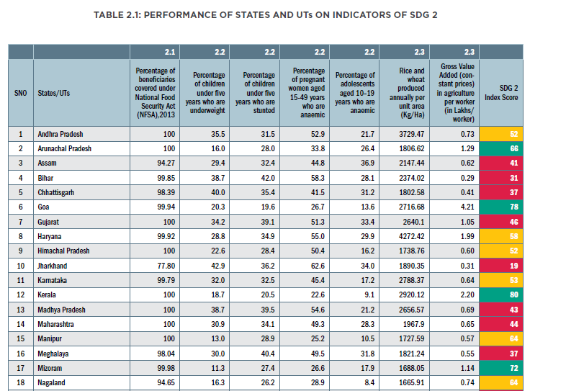

We are concerned that these indicators would have increased considerably following the pandemic and unplanned lockdown.
The decision by the Department of Public Instruction to provide eggs to children in government and aided schools in seven districts of Karnataka from December 2021 onwards covering around 14.44 lakh students of class one to eight thrice a week is a long pending move and a case of too little, too late.
Poor implementation of mid-day meal scheme during lockdown
The aim of the Akshara Dasoha (mid-day meal scheme) in Karnataka was both educational and nutritional – to increase school enrolment and attendance, decrease dropout rates, promote good health through nutritional foods and increasing learning ability of children.
Post pandemic, all of these objectives lie in total shambles for almost 53,47,501 students in government schools the state of Karnataka and the government seems to be in no great rush to address it.
The failure to reopen government-run and government-aided schools or even provide the legally mandated Mid-day meals/dry rations is a gross violation of children’s right to food and nutrition guaranteed under the National Food Security Act 2013. Additionally, the provisioning of milk (powder) under the Ksheera Bhagya programme of the government has also been discontinued since June 2020. Although ration kits had been provided for five months for three months till May, there were no ration kits for five months from June to October.
Inclusion of eggs in the Mid-day Meal Scheme
As per National Institute of Nutrition (NIN) and demands from civil society, nutritionists doctors, advocates, parents, children etc., eggs should be mandatory in mid-day meals owing to its numerous nutritional benefits. Karnataka has been the only southern Indian state that has consistently refused to provide eggs as part of MDM, largely for religious reasons, inspite of 94% students in these schools belonging to communities that eat eggs. According to the National Family Health Survey-4 (2015-16) at least 83% of the state’s population doesn’t have any cultural or religious objections to consumption of eggs.
The provision of egg is important because it is a low-cost, easy to cook, culturally acceptable and locally available alternative with high Protein component with biological value of 100 as compared to 60-70 for pulses (daal) and a good source of all vitamins except C. The possibility of adulteration is less and monitoring the stock supply is easier. Children who cannot consume eggs can be offered a seasonal fruit, additional milk or curd.
Karnataka has largely resisted providing eggs in mid day meals inspite of the concerning levels of malnutrition in the State inspite of 94% children belonging to these schools are used to eating eggs. States like Tamil Nadu and Andhra Pradesh with budgets comparable to Karnataka provide eggs 5 times a week. Karnataka would need an allocation of 370 crores for three eggs a week and 617 crores for 5 eggs a week. (5% administrative expense, 44 weeks of schooling a year @Rs 5/egg). This would be approximately 2.32% of total education department budget and 0.05% of the GDP.
We, the undersigned are extremely concerned at how what is a straightforward nutritional intervention for the children of the state is being embroiled in so much of ideological and economic jugglery essentially denying a basic nutrient dense food to lakhs of children over the last several years.
Malnutrition should be prevented not treated – why leave out the other districts and why only 3 eggs a week?
In Karnataka 35.4% children under 5 are stunted, and 32.9% are underweight (<-2 SD). If we calculate the <-1 SD, the numbers will shoot up). When nutrition indicators are already so bad, why is the State government only picking on 7 districts for the intervention of providing eggs. Are they waiting for all the other districts to also go into malnutrition before including them into intervention? Many nutritional deficiencies have long term and often irreversible consequences. For children prevention of malnutrition is crucial, not waiting for it to happen and then addressing it.
Now that the state government has finally decided to provide eggs, this again seems to be a halfhearted effort covering only 7 districts. This is like saying we won’t make any efforts at preventing smoking, but will treat the lung cancer when it occurs. It is also well known that 5 eggs a week have numerous nutritional benefits, so why have only 3 eggs a week? The question that begs to be answered is why wait till children go into severe malnutrition to even think of an intervention? Why can the Government of Karnataka not proactively work to preventing malnutrition in the state?
In addition, we must remember that though levels of stunting and undernutrition have marginally improved in Karnataka, these are only the severe forms. (severe is less than -2 SD and very severe is less than -3 SD). We do not have clear estimates of moderate malnutrition (<-1 SD) and the focus of any government should be to address nutritional deficiencies before they go into the severe category and ideally prevent malnutrition in the first place. One of the factors that contributes to India’s low ranking of 101 out of 116 countries in the Global Hunger Index is the rate of child stunting. A properly planned school meal but a proactive government can go a long way in addressing/preventing a malnutrition crisis.
Millets and fortification are not the solution to malnutrition – diverse diet is key
The government is now pushing for mandatory fortification of rice with iron, folic acid and B12 as a solution to address nutritional deficiencies and millets are also being pushed as a way to address malnutrition
It must be remembered that both millets and cereals belong to the same food group. While they can have a role in meeting the energy needs of the population, these are not nutrient dense foods and cannot provide the required protein, vitamin and mineral needs of the population, especially the most vulnerable.
Considering that the rates of stunting and underweight in children under 5 are high as in Karnataka, the possibility of multiple nutritional deficiencies are also high. Because iron deficiency commonly measured, it doesn’t mean that replacing only iron will solve the nutritional problems. There is a need for multiple nutrients and good quality proteins. These can only come from nutrient dense and diverse foods such as dairy/milk, oils/fats, eggs, meat, fish and poultry, legumes/pulses, vegetables.
Fortification will only increase costs, increase dependence on companies (premixes have to be flown or shipped in from other countries), reduce shelf life and take away the food sovereignty of communities.
Traditionally people are used to eating animal meats, poultry and fish and this has also supported local economy and prevented families from falling into dire poverty. By bringing in the poorly thought-out cattle slaughter ban in February 2021, the government of Karnataka has, with a single stroke, destroyed the entire cattle economy as well as adversely impacted the access of many communities to what is a nutrient dense food.
There has not been much government support to strengthen poultry/fishing/livestock rearing for small communities. Encouraging community kitchen gardens, school-based kitchens and the addition of foods from different food groups especially the nutrient dense animal source foods is a first step. Instead of doing this, jumping straight to company supported fortification shows that the government has no real interest in addressing malnutrition but is still largely driven by the caste corporate agenda.
It is also important that the children understand the importance of good nutrition that is diverse and balanced and drawn from their own culture. What better place to inculcate good food practices than the mid-day meal? Instead, this scheme is now being used to promote sattvik diets that have no nutritional value and are instead based on ideological or unscientific premises. This again being propagated through centralized kitchens run by NGOs that refuse to use onion and garlic thus openly flouting state government menu guidelines.
The way forward
We demand that the government urgently take following measures:-
- Immediate provision of dry rations for all the pending months since May, and no further delays in future. The mid day meals and anganwadi meals which are a legal mandate have to be started immediately.
- Extra effort has to go to ensure that children in tribal belts, dalit children, children from OBC communities are not left out.
- Schools have to be reopened immediately and school-based kitchens should be set up. All centralized contracts should be cancelled immediately.
- Milk or milk powder should be provided to the school-children under the Ksheera Bhagya scheme of the state government for all pending months since July and on a regular and prompt basis for the subsequent months till the opening of the schools.
- Eggs at the rate of at least 5 per week per child should be mandatorily provided to the children in all the 31 districts of Karnataka. the contract for the supply should be given to local self-help or women’s groups to support the livelihood of communities as well.

- Subsidise all animal source foods such as dairy, poultry, fish, meat.
- The cattle slaughter ban which has been in effect since February 2020 has to be lifted.
- The focus should move from cereals/millets and fortification to a more diverse and nutrient dense diet.
- To provide all the above said entitlements state as duty bearer should enhance the per child unit cost of the nutritional meal.
Signed by
- Ahara namma hakku (Our food our right)
- …..
- …..
- …..
- ……..

