**A note on SCHOOL AND CLASSROOM PROCESSES ONCE SCHOOLS REOPEN**

1. **Curriculum reconfiguration**
   1. The curriculum must be reconfigured to focus on key learning outcomes from the current academic year (2021-22) and what had to be completed during the last academic year (2020-21).
   2. This exercise must be carried out in a judicious manner (as opposed to a simple reduction of textbook chapters), identifying outcomes that are necessary for further learning as well as the socio-emotional development of the students.
   3. What is realistically possible in the remaining academic year, given the situation, must be carefully considered at the same time.
   4. During the curriculum revision process, concepts can be categorised into three kinds - this will cater to the possibility of reduced school timing (allowing children to learn independently at home) as well as any sudden school closures. These categories are:
2. Concepts learnt by full teacher support: New and complex concepts that will need sustained teaching learning efforts.
3. Concepts learnt by partial guidance: simple concepts that can be learnt with support from peers/others/some extra time of the teacher.
4. Concepts learnt through self-learning: that can be learnt by children with minimal support.
5. **Prioritizing Student Learning Outcomes, Syllabus and Assessment Methods**
6. SCERT must set up a curriculum redesign committee to decide the learning outcomes for the year for Grades 1-10.
7. Based on this, the syllabus, textbook content and teaching-learning materials will need to be reorganized.
   1. A list of chapters from the textbook aligned to the learning outcomes could be decided and the rest of textbook chapters could be used as supplementary reading.
   2. A repository of stories, songs, games, puzzles/riddles, worksheets for children of all classes will need to be developed to aid in teaching.
8. Priority must be given to content that is relevant to developing dispositions necessary for the prevalent situation, such as resilience, care, sensitivity, and empathy.
9. Systematic lesson plans must be made available and active learning methodology enabled during school hours to maximize student learning.
   1. Provide/develop clear lesson plans that list the learning outcomes to be achieved, chapter to be transacted, resources to be used, activities to be conducted, and home assignments to be provided as follow up.
   2. Use teaching-learning processes/such modes of interactions with students which maximize learning e.g. where children are ‘doing’ things which they can follow-up/ practice further at home; bridge activities to address the gap between the earlier and the new class, etc.
   3. Assign project work to older children to enable self-learning; this can be from the syllabus areas that are not addressed in the school hours.
   4. Assess ongoing progress through classroom assessments.
10. **Prioritizing learning outcomes is illustrated in the samples below.**
11. **Sample 1: Hindi – this sample can be generalized for other first languages.**
12. The curricular expectation of language at the primary level is to enable children to:
    * + - Acquire the skills of listening, speaking, reading, writing and thinking in an integrated manner.
        - Develop interpersonal communication skills, attain basic proficiency like, developing ability to express one’s thoughts orally and in writing in a meaningful way.
        - Interpret and understand instructions and polite forms of expression, and respond meaningfully both orally and in writing.
        - Develop reference skills in both printed and electronic mode.
        - Acquire a varied range of vocabulary; understand increased complexity of sentence structures both in reading and writing.
        - Express an awareness of social and environmental issues.
        - Read and interpret critically the texts in different contexts– including verbal (including Braille) and pictorial mode.
13. **In the current situation, the learning outcomes of Grades 1-5 for Language can be prioritized as below:**

|  |  |
| --- | --- |
| ***Grades 1-2*** | ***Grades 3-5*** |
| 1. Develop the skill of listening comprehension and the connection between sounds and words 2. Develop basic reading and writing skills 3. Understand events occurring in the surroundings and express them orally | 1. Ability to read and write independently 2. Ability to comprehend textual materials presented in different forms like poems, stories, notice boards, posters, etc 3. Ability to express one’s thoughts with confidence in oral and written forms 4. Understand the basic structure of the language and apply it in writing |

1. **To meet the above learning outcomes, the syllabus could be selected on the following basis:**
2. For Grades 1-2, emphasis on picture reading/visually appealing materials, connecting to printed materials in textbooks, using that as the basis for familiarization with script.
3. Activities that give plenty of space to children to talk, engage in dialogue and express in class; children should be given systematic opportunities to share stories, recite rhymes, folk songs, etc to get used to the language.
4. Opportunities to listen to plenty of interesting stories and poems – such stories/poems can be selected that are distinct from each other, have different contexts, different genres. The number of poems/stories in the syllabus can be halved.
5. Text that highlights the importance of safe health and hygiene must be identified.

1. **A detailed sample for Grade 4, based on the Rimjhim textbook (NCERT) content is below. The number of chapters have been reduced based on the learning outcomes above.**

|  |  |  |  |
| --- | --- | --- | --- |
| ***Chapter No.*** | ***Name of chapter*** | ***Reason for selection*** | ***Suggestions for pedagogy and assessment*** |
| ***Ch-1*** | Man Ke Bhole Bhole Badal (poem) | Encourages children to observe and imagine, exposure to language, well- integrated with EVS. | Read the stories and poems aloud with detailed explanations.  Practice read aloud sessions with children with adequate voice modulation and intonations.  Discuss the stories, ask questions in between the stories to check for understanding.  Perform short activities like role plays and skits to make children enact the stories, practice dialogues and use language.  Conduct group activities, like spelling and dictation, making charts on types of clouds, types of food, etc based on the chapters, singing rhymes/local songs and explaining the meaning.  Provide homework for days when children are at home that is well connected to the lesson e.g. drawing something based on the theme of the lesson, writing a few  sentences, doing a worksheet given in the textbook.  Assessment should be ongoing: based on observation, how children participate in group activities and worksheets given for home work. |
| ***Ch- 2*** | Jaisa Sawal Vaisa Jawab (story) | Has a historical context. Uses the Akbar-Birbal duo, introduces children to humour style of writing. Encourages children to develop the skill to think critically and ask questions. |
| ***Ch-7*** | Daan ka Hisaab (story) | Gives children the exposure to develop skills of logical reasoning, develop sensitivity, analysis of present context. Can be integrated with games in mathematics, EVS topics such as natural calamities. |
| ***Ch- 9*** | Swatantrata ki Or (Essay) | Instills patriotism, courage and understanding of society. Exposure to freedom movement, issues of exploitation and human rights, contributions of Mahatma Gandhi. |
| ***Ch- 10*** | Thapp Roti Thapp Daal (children’s play) | Exposure to diverse genre of writing. Opportunities for skits and role plays. Can be integrated with EVS- discussion on sources of food, differences in culture, etc. |
| ***Ch- 12*** | Sunita Ki Pahiya Kursi (story) | Develop sensitivity to people who are differently abled. Exposure to diversity  – issues of gender. |
| ***Ch- 14*** | Muft Hi Muft (Gujarati Lok- katha) | Exposure to people living in diverse geographical context and their lifestyles. Familiarizes with geography of Gujarat. |

1. **Sample 2: Science – Grades 6-8**
   * 1. This sample is based on NCERT science textbooks, which are used in most states across the country.
     2. The learning outcomes in science are articulated in such a way that they can be achieved while dealing with any content/chapter in the textbook. Therefore, the focus should be on achieving the learning outcomes with a limited number of chapters. This can be addressed through either class work or project work. For example, in Grade 6:
        + The learning outcome ‘differentiates materials and organisms’ can be achieved through helping learners understand the differences between fibre and yarn, tap and fibrous roots, electrical conductors and insulators, etc, based on properties, structure and functions.
        + The learning outcome ‘explains processes and phenomenon’ can be achieved through helping learners explain processes and phenomenon related to movements in plants and animals, formation of shadows, reflection of light in plane mirror, variations in composition of air, preparation of vermicomposting, etc.
        + The learning outcome ‘classifies materials, organisms and processes based on observable properties’ can be achieved through helping learners classify materials as being soluble, insoluble, transparent, translucent and opaque; changes as those that can be and cannot be reversed; plants as herbs, shrubs, trees, creeper, climbers; components of habitat as biotic and abiotic; motion as rectilinear, circular, periodic; and so on.
     3. There are common learning outcomes across the grades that are spirally linked through content and its complexity. For example, Changes Around Us in Grade 6 culminates to Physical and Chemical Changes in Grade 7. This enables revisiting similar content in multiple years with increasing depth. Therefore, the suggested approach is to prioritize some chapters in classroom teaching and others through project work that the learners can do independently. Thus, the content on Fibre to Fabric in Grade 6 can be given as project work in the current academic year, and can be dealt with through classroom teaching the following year.
     4. In this way, the syllabus can be reduced to 50% by focussing on the achievement of learning outcome and not on the coverage of content.
     5. Content selection – List of chapters Grades 6-8.

|  |  |  |
| --- | --- | --- |
| ***Grade*** | ***Chapters primarily for regular teaching*** | ***Chapters primarily for project work*** |
| ***6*** | Food: Where does it come from - Chapter 1 Components of Food - Chapter 2 Separation of substances - Chapter 5 Changes around us - Chapter 6  Getting to know plants - Chapter 7 Body movements - Chapter 8  The living organisms -  Characteristics and habitats - Chapter 9  Motion and measurement of distances - Chapter 10  **8 Chapters** | Fibre to fabric - Chapter 3  Sorting materials into groups - Chapter 4 Light, Shadows, and reflections - Chapter 11 Electricity and circuits - Chapter 12  Fun with magnet - Chapter 13 Water - Chapter 14  Air around us - Chapter 15  Garbage in, Garbage out - Chapter 16  **8 Chapters** |
| ***7*** | Nutrition in plants - Chapter 1 Nutrition in animals - Chapter 2 Heat - Chapter 4  Acids, bases, and salts - Chapter 5 Physical and chemical changes - Chapter 6 Respiration in organisms - Chapter 10  Transportation in animals and plants - Chapter 11 Reproduction in plants - Chapter 12  Motion and time - Chapter 13  **9 Chapters** | Fibre to Fabric - Chapter 3 Soil - Chapter 9  Weather, climate and adaptations of animals to climate - Chapter 7  Winds, storm, cyclones - Chapter 8 Electric current and its effect - Chapter 14 Light - Chapter 15  Water a precious resource – Chapter 16 Forests: Our lifeline - Chapter 17 Wastewater story - Chapter 18  **9 Chapters** |

|  |  |  |
| --- | --- | --- |
| ***8*** | Microorganisms: Friend and Foe - Chapter 2 Metals and non-metals - Chapter 4  Cells - Chapter 8  Reproduction in animals –Chapter 9 Reaching the age of adolescence - Chapter 10 Sound - Chapter 13  Chemical effect of electric current - Chapter 14 Light - Chapter 16  Stars and solar system - Chapter 17  **9 Chapters** | Crop production and management - Chapter 1 Synthetic fibres and plastics - Chapter 3  Coal and petroleum - Chapter 5 Combustion and flame - Chapter 6  Conservation of plants and animals - Chapter 7  Forces and pressure - Chapter 11 Friction - Chapter 12  Some natural phenomenon - Chapter 15 Pollution of air and water - Chapter 18 **9 Chapters** |

* + 1. Suggested pedagogical processes and assessment processes:
       - Giving explanations of key concepts, doing experiments, group activities to actively engage with the core scientific facts.
       - Giving projects on chapters to be done at home, as mentioned above, with clear instructions on what to do; teachers can use projects as resources to teach other grades.
       - Students reading literature on their own, including textbook chapters.
       - Providing several worksheets or survey tasks to students before the teacher starts teaching the topic in the classroom. This would help students in actively engaging with the content. This would help save time during classroom teaching.
       - Another strategy is teaching different chapters as a coherent unit and not as isolated topics. For example, in Grade 6, Getting to know plants (Chapter 7) can be integrated with Food: Where does it come from (Chapter 1). Similarly, integrating content in different subjects like science and geography (motion of the earth, major domains of the earth, climate vegetation and wildlife) could also be explored.
       - Evaluating students’ project work, worksheet-based assessment, homework, allowing students to do peer and self-assessment, short conceptual quizzes, etc would provide a good source of assessment. Teachers’ judgements in attaining learning outcomes against appropriate tasks would be a strong assessment tool.
       - An effective assessment strategy would be providing students books and magazines to read and discuss. That would not only evaluate students’ science content, but also other subjects and languages.

**Sample worksheets**

***Grade 1, Language***

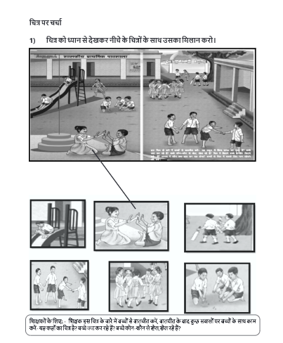

***Grade 3, Language***

**Annexure 3: School reopening across the globe**

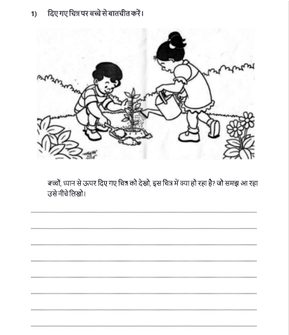

***Grade 5, Language***

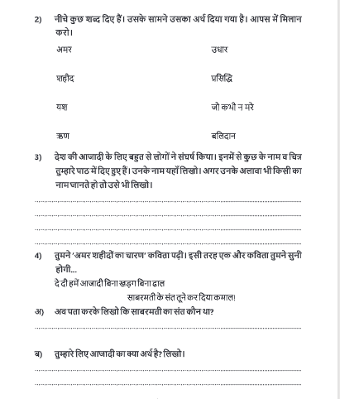

***Grade 1, Mathematics***

